# EMA Crossover Signal Strategy

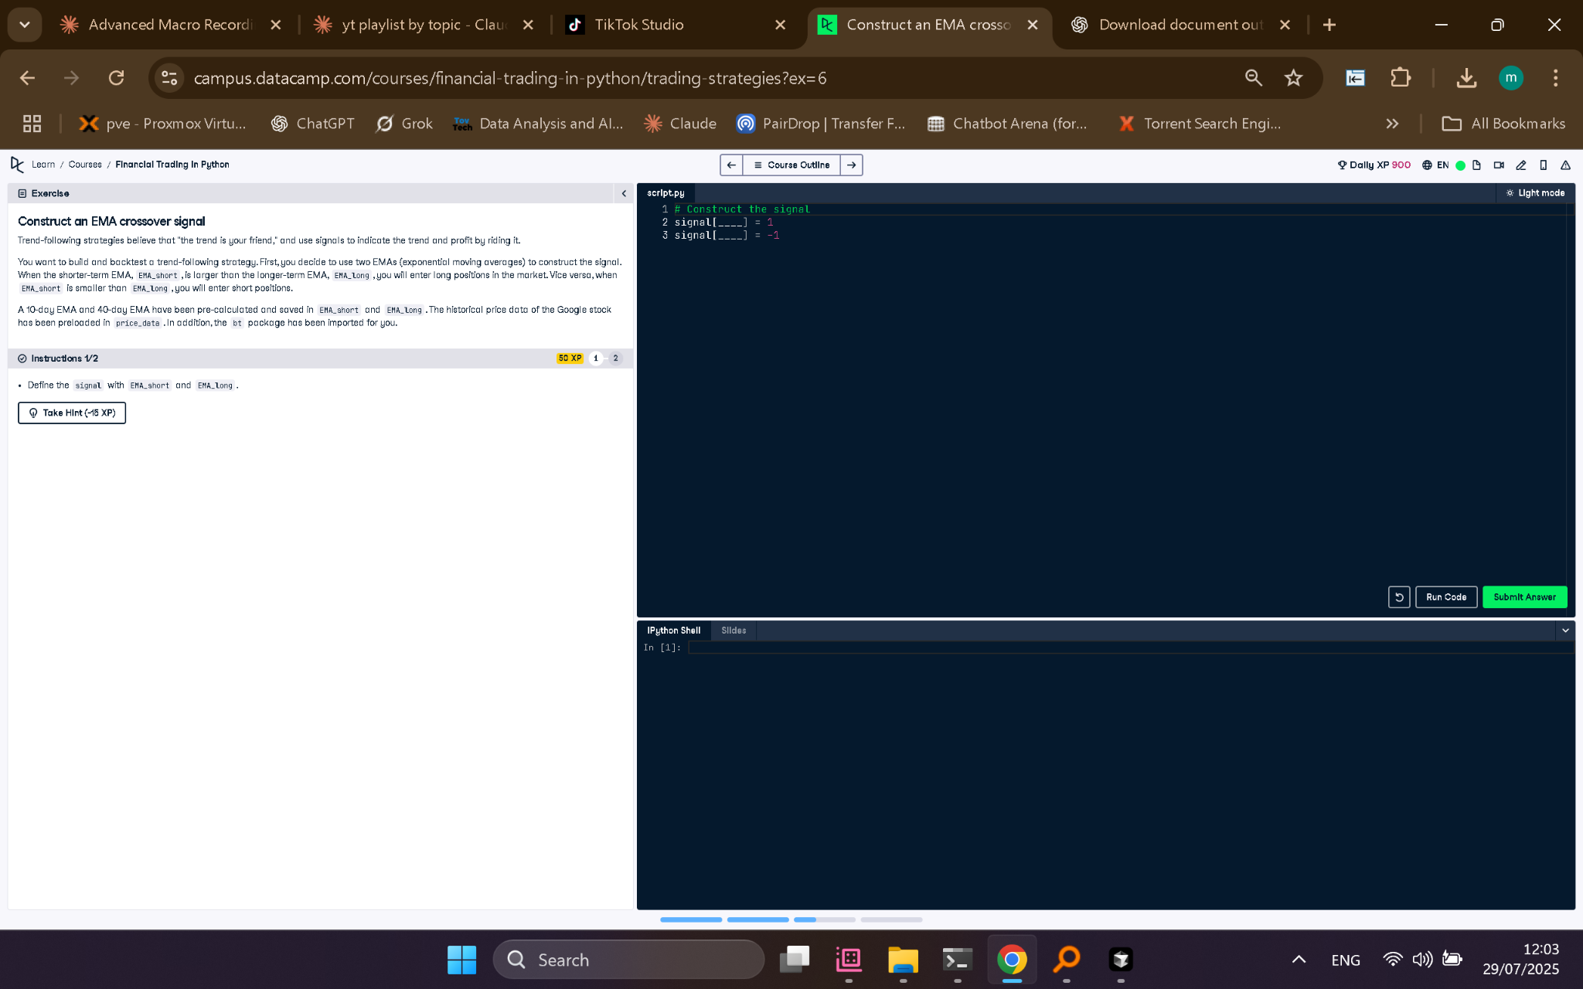

## Python Code

# Construct the signal  
signal[EMA_short > EMA_long] = 1  
signal[EMA_short < EMA_long] = -1

## Explanation (50 words)

This strategy creates a trading signal using two EMAs: short and long term. It signals 'buy' (1) when the short EMA crosses above the long EMA, and 'sell' (-1) when it crosses below.